Bonfleur Cross Country Course Disclaimer Form
And Terms and Conditions of Use
Horse riding, especially Cross Country riding, is and always will be, a high risk sport. By following the rules and guidelines given we hope to keep these risks to an absolute minimum.
- The jumps are of varied height, nature and levels of difficulty. The decision to jump is ultimately the responsibility of the rider; the rider alone has to decide upon the limits in performance and the ability of his/her horse/pony. For this reason it is essential that you inspect each jump before you jump to ensure that it is safe for you.
- Hats MUST BE WORN AT ALL TIMES when mounted and to the current British Equestrian Trade Association (“BETA”) standard.
- Back protectors to meet the current BETA Standard must also be worn when mounted.
- In the interests of safety it is compulsory that all riders are accompanied by a responsible adult when at Bonfleur.
- It is compulsory to give way to members of the public using the public footpaths that cross the course. It is compulsory that you make yourself aware of their location before riding, please turn over to see location map.
- It is compulsory that all dogs are kept on leads at all times.
- It is compulsory that all gates are closed.
- It is compulsory that you read and obey signs and notices on the site at Bonfleur.
DISCLAIMERS
- Neither the proprietors, nor any employee nor any person acting on their behalf, accept any liability for any loss, damage, accident, injury or illness to horses, owners, riders, spectators or any other persons or cars and contents or property under any conditions whatsoever.
- The proprietors of Clock House Farm and Bonfleur Cross Country Course have taken reasonable precautions to ensure the Health & Safety of everyone who uses the course. For these measures to be effective, everyone must take reasonable care to avoid and prevent accidents occurring and MUST OBEY any rules and instructions given.
ANY PERSON USING THE CROSS COUNTRY COURSE DOES SO ON THE UNDERSTANDING THAT THEY HAVE READ AND AGREED THESE TERMS AND CONDITIONS SET OUT IN THIS DOCUMENT
PLEASE SIGN BELOW to acknowledge acceptance of Terms and Conditions and disclaimers set out above in this document. (Anyone under 18 must be signed for by their parent or guardian. If this is the case, please also write the child’s name in the 3rd column) please note if you are not in acceptance of the terms and conditions and disclaimers on this form you are not entitled to use the facilities at Bonfleur Cross Country Course.
Date | Print Name | Signature | Name of child you are responsible for (if applicable)
Page 1 of 2
Please turn over

PLEASE SIGN BELOW to acknowledge acceptance of Terms and Conditions and disclaimers set out on the other side of this page in this document. (Anyone under 18 must be signed for by their parent or guardian. If this is the case, please also write the child’s name in the 3rd column) please note if you are not in acceptance of the terms and conditions and disclaimers on this form you are not entitled to use the facilities at Bonfleur Cross Country Course.
Date | Print Name | Signature | Name of child you are responsible for (if applicable)
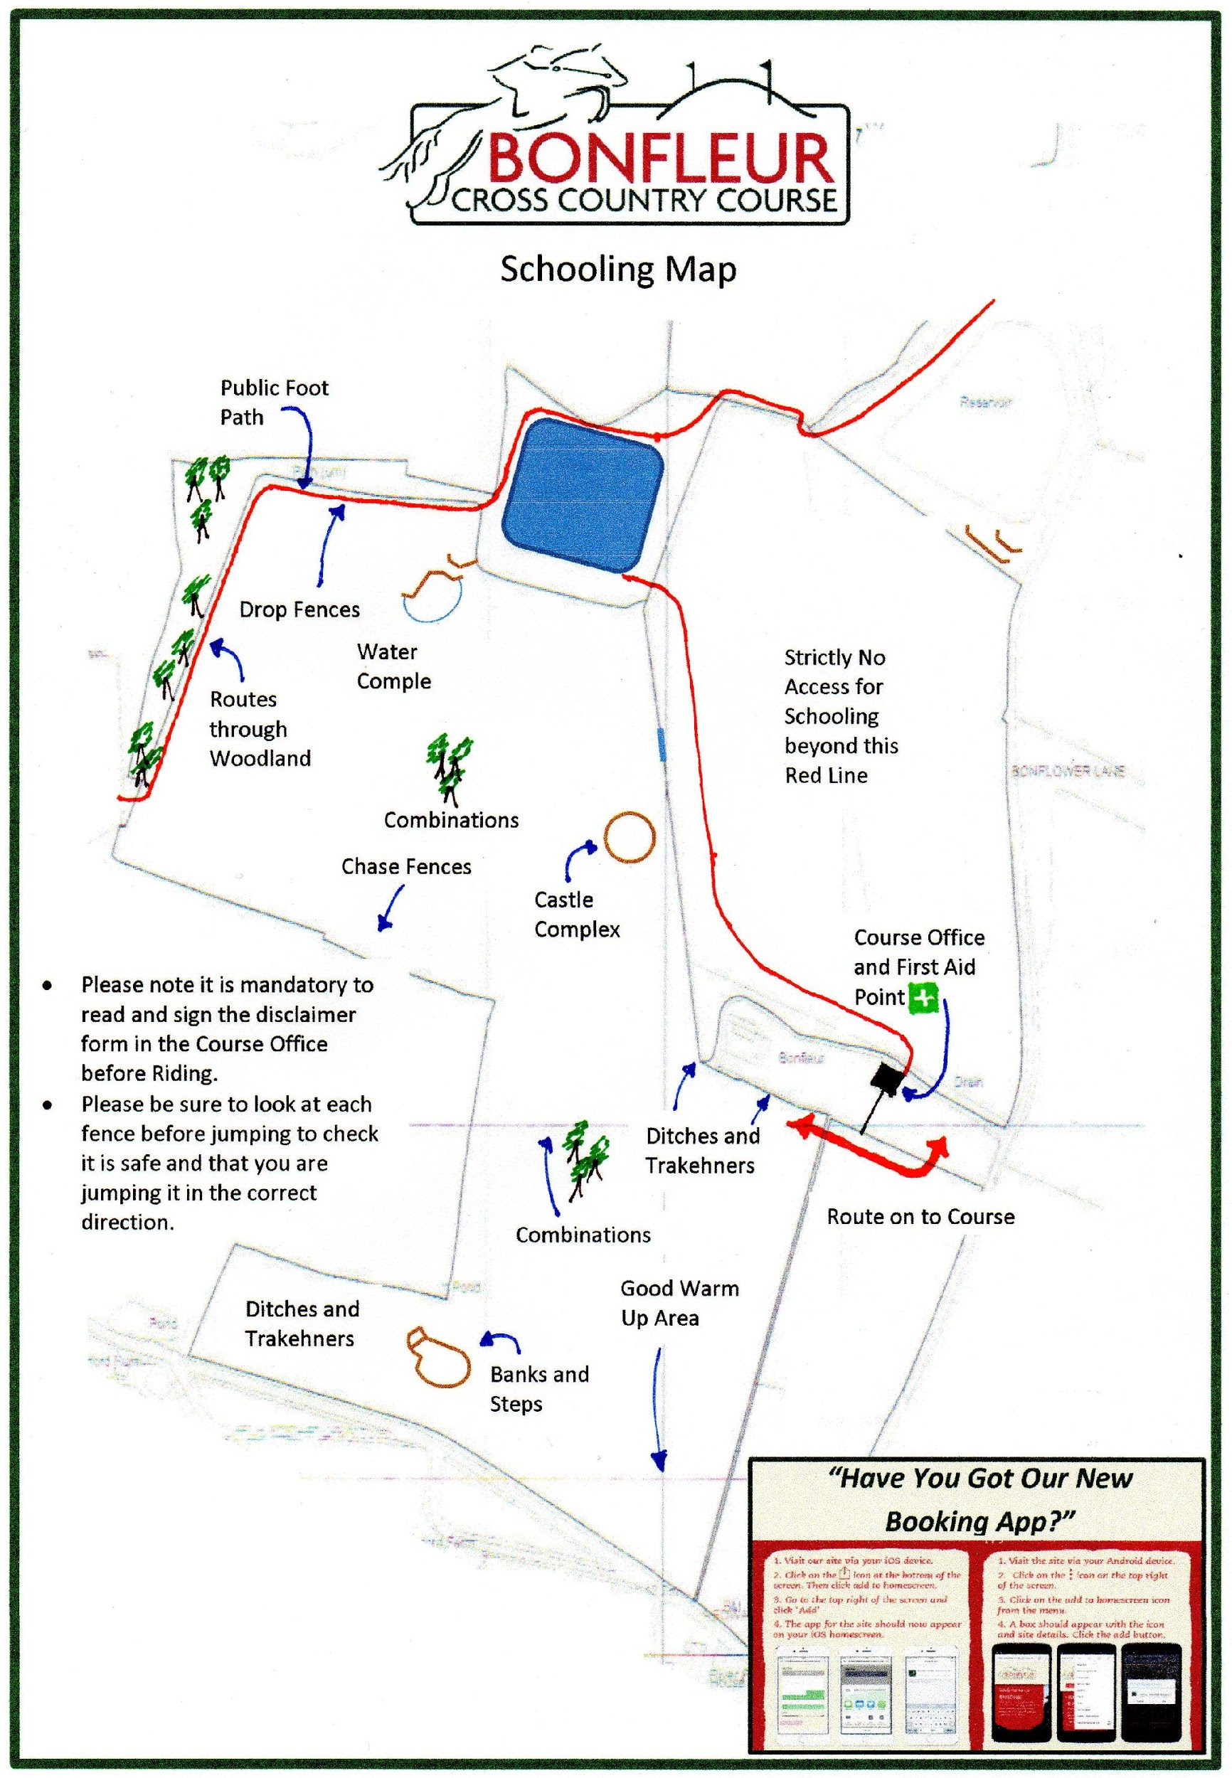
If the maps above are too small for you to read, please see larger A4 version in the office
at Bonfleur Cross Country Course.

Map Showing Location of Public Foot Path

Page 2 of 2

If you find these maps too small to read please see A4 version in the cross country course office at Bonfleur.

